Analysis and Specification of Requirements

Quiz examination system

Version 1.1

Contents
Analysis and Specification of Requirements 1
Quiz examination system 1
Version 1.1 1
Contents 2
Introduction Quiz Examination System 1
I. Functional Requirements of the Quiz Examination System 1
1. Log in and manage your account 1
2. Management of subjects and topics 2
3. Question bank management 2
4. Create and manage tests 3
5. Take the test 3
6. Score and view results: 4
7. View test-taking history : 5
8. Results management and statistics 5
9. System administration 5
II. Non-Functional Requirements 6
Usability : The responsive interface automatically adjusts to screen size, allowing users to access the system on desktop computers, laptops, tablets, and smartphones. 6
Reliability : The system must ensure that students' work is fully saved during the examination and that the results, once submitted, are not lost or unintentionally altered. 6
Performance : The system must respond quickly to actions such as logging in, loading questions, saving answers, and submitting work, especially during periods when many students are taking the test simultaneously. 6
Security : Students are permitted to access only their own tests, submissions, and results. The system must protect account data and defend against common attack vectors such as SQL Injection and XSS. 6
Design Constraints : 6
III. Data Flow Diagram 7
1. Diagram Overview 7
7
IV. Use case Diagram 9
1. Summary diagram 9
1.1 List of actors 9
1.2 List of use cases 10
2. Use-case Login 11
2.1 Summary 11
2.2 Timeline of events 11
2.2.1 Key timeline of events 11
2.2.2 Other timelines 12
2.3 Special requests 12
2.4 System state prior to the execution of the use case 12
2.5 System state after executing the use case 12
2.6 Extension point 12
3. Use-case Register Account 12
3.1 Summary 12
3.2 Event Flow 12
3.2.1 Main Event Flow 12
3.2.2 Alternative Event Flows 13
3.3 Special Requirements 13
3.4 System state prior to the execution of the use case 13
3.5 System state after executing the use case 13
3.6 Extension point 13
4 Use-case Update Information 13
4.1Summary 13
4.2 Timeline of events 13
4.2.1Key timeline of events 13
4.2.2 Other timelines 13
4.3 Special requests 14
4.4 System state prior to the execution of the use case 14
4.5 System state after executing the use case 14
4.6 Extension point 14
5 Use-case View Test 14
5.1 Summary 14
5.2 Timeline of events 14
5.2.1 Key timeline of events 14
5.2.2. Other event streams 14
5.3 Special requests 14
5.4 System state prior to the execution of the use case 15
5.5. System state after use case execution 15
5.6. Extension points 15
6. Use-case Take The Test 15
6.1 Summary 15
6.2 Timeline of events 15
6.2.1 Key timeline of events 15
6.2.2. Other event streams 15
6.3. Special requirements 16
6.4. Precondition 16
6.5. System state after use case execution 16
6.6. Extension points 16
7. Use-case Start Test 16
7.1. Summary 16
7.2. Timeline of events 16
7.2.1. Main sequence of events 16
7.2.2. Other event streams 17
7.3. Special requirements 17
7.4. System state prior to executing the use case 17
7.5. System state after use case execution 17
7.6 Extension point 17
8. Use-case Answer Questions 17
8.1. Summary 17
8.2. Timeline of events 17
8.2.1. Main sequence of events 17
8.2.2. Other event streams 18
8.3. Special requirements 18
8.4. System state prior to the execution of the use case 18
8.5. System state after use case execution 18
8.6. Extension points 18
9. Use-case Submit Assignment 18
9.1. Summary 18
9.2. Timeline of events 18
9.2.1. Main sequence of events 18
9.2.2. Other event streams 18
9.3. Special requirements 19
9.4. System state prior to the execution of the use case 19
9.5. System state after use case execution 19
9.6. Extension points 19
10. Use-case View Result 19
10.1. Summary 19
10.2. Timeline of events 19
10.2.1. Main sequence of events 19
10.2.2. Other event streams 20
10.3. Special requirements 20
10.4. System state prior to the execution of the use case 20
10.5. System state after use case execution 20
10.6. Extension points 20
11. Use-case Course and Topic Management 20
11.1. Summary 20
11.2. Timeline of events 20
11.2.1. Main sequence of events 20
11.2.2. Other event streams 21
11.3. Special requirements 21
11.4. System state prior to Use-case execution 21
11.5. System state after use case execution 21
11.6. Extension points 21
12. Use-case Question Bank Management 21
12.1. Summary 21
12.2. Timeline of events 21
12.2.1. Main sequence of events 21
12.2.2. Other event streams 22
12.3. Special requirements 22
12.4. System state prior to the start of the use case execution 22
12.5. Trạng thái hệ thống sau khi thực hiện Use-case 22
12.6. Extension points 22
13.Use-case Test Management 22
13.1. Summary 22
13.2. Timeline of events 22
13.2.1. Main sequence of events 22
13.2.2. Other event streams 23
13.3. Special requirements 23
13.4. System state prior to the start of the use case execution 23
13.5. System state after use-case execution 23
13.6. Extension points 23
14. Use-case View Results and Statistics 24
14.1. Summary 24
14.2. Timeline of events 24
14.2.1. Main event stream 24
14.2.2. Other event streams 24
14.3 Special requests 24
14.4. System state prior to the start of the use case execution 24
14.5. System state after use-case execution 24
14.6. Extension points 25
15. Use-case User Management 25
15.1. Summary 25
15.2. Timeline of events 25
15.2.1. Main sequence of events 25
15.2.2. Other event streams 25
15.3. Special requirements 25
15.4. System state prior to Use-case execution 25
15.5. System state after executing the use case 26
15.6. Extension point 26
16. Use-case Data Management 26
16.1 Summary 26
16.2 Timeline of events 26
16.2.1. Main sequence of events 26
16.2.2. Other event streams 26
16.3. Special requirements 26
16.4. System state prior to the start of the use case execution 27
16.5. System state after use case execution 27
16.6. Extension points 27
Class Diagram 27
1. Diagram Overview 27
DATABASE MODEL 28
1. Diagram Overview 28
VII. Interface Design Description 28
1. Login Interface 28
2. Student Interface 29
3. Quiz Examination Interface 29
4. Teacher Interface 30
5. Result Interface 31
6. Administrator Interface 31

Introduction Quiz Examination System
The Quiz Examination System is a platform that supports the organization and management of online tests. It enables teachers or administrators to create, update, and manage exams, questions, and answers. Meanwhile, students can log in, take tests, submit their work, and view their results upon completion.
The system was developed to digitize the testing process, thereby reducing the time and effort required to create exam questions, organize exams, and grade papers. Additionally, it supports result storage and provides statistical data, enabling teachers to easily monitor and evaluate students' academic performance.
The system's primary users include administrators, teachers, and students. Administrators are responsible for managing accounts and general system information. Teachers manage questions and create and organize tests. Students use the system to take tests and track their results.

- Functional Requirements of the Quiz Examination System
The Quiz Examination System is designed to support the entire process of organizing and conducting online tests, ranging from user management, question bank development, and test creation to administration, grading, and results management.

- Log in and manage your account
- Log in to the system:
+ Users can log in using their username/email and password.
+ A system that verifies login credentials and determines user roles.
+ If the login information is correct, the system grants the user access to functions corresponding to their permissions.
+ If the login information is incorrect, the system displays an error message and prompts the user to re-enter it.
- Register an account:
+ Students can register for a new account to use the system.
+ Registration information may include full name, email, password, date of birth, and other necessary personal information.
+ A system to check whether the registration email already exists in the system.
+ If the email is already in use, the system notifies the user and asks them to use a different email.
- Update personal information:
+ Users can update their personal information.
+ Users can change their passwords when necessary.
+ The updated account information will be saved in the system.
- Recover password:
+ Users can use the password recovery function if they forget their password.
+ The system requires the user to provide their registered email.
+ After verifying the information, the system assists the user in creating or retrieving the necessary login details.
- Management of subjects and topics
+ Teachers can create and manage subjects used within the system.
+ Each subject may comprise various topics.
+ Teachers can add, edit, or delete information regarding subjects and topics.
+ Students can view the list of courses and the tests associated with their assigned courses.
- Question bank management
- More questions:
+ Teachers can create new questions and add them to the question bank.
+ Each question includes content, answer options, and the correct answer.
+ Questions can be assigned to a specific subject or topic.
+ Teachers can set the difficulty level of questions such as easy, medium, or hard.
- Update question:
+ Teachers can edit the question content, answer options, and the correct answer.
+ Teachers can change the subject, topic, or difficulty level of the questions.
- Delete question:
+ Teachers can delete questions that are no longer in use.
+ The system needs to check the usage status of a question before deleting it to avoid affecting tests that have already been created.
- Search for questions:
+ Teachers can search for questions using keywords
+ You can filter questions by subject, topic, or difficulty level.
+ The system returns a list of questions matching the search criteria.
- Create and manage tests
- Create a test:
+ Teachers can create a new test.
+ Each test includes the test title, subject, time limit, start time, end time, and number of questions.
+ Teachers can select questions from the question bank to include in the test.
+ Teachers can set points for each question.
- Edit the test:
+ Teachers can update test information before the test takes place.
+ Teachers can add or remove questions from the test.
+ Teachers can modify the timing and settings of the test.
- Publish the test:
+ Teachers can publish the test for students to take.
+ Teachers can set up groups or lists of students permitted to participate.
+ The test can only be taken during the specified time period.
- Delete test:
+ Teachers can delete tests that are no longer in use.
+ The system needs to check the status of the test before performing the deletion operation.
- Take the test
- View the list of tests:
+ Students can view their assigned tests.
+ The list displays basic information such as the test name, subject, duration, and start time.
+ Students can view the status of a test for example, not yet started, in progress, or finished.
- Start the test:
+ Students select the test and use the function to start the exam.
+ System for checking eligibility and test duration.
+ If eligibility requirements are met, the system generates a test session and begins the timer.
- Complete the exercise:
+ The system displays the questions and answer options.
+ Students can select an answer for each question.
+ The system records the answers selected by students.
+ Students can change their answers before submitting their work.
+ The system displays the time remaining during the test.
- Submit assignment:
+ Students can submit their work at their own discretion once they have completed it.
+ Before submission, the system may require students to confirm the action.
+ Once the assignment is submitted, students cannot continue to change their answers.
+ If the allotted time expires, the system automatically submits the test with the recorded answers.
- Score and view results:
+ After students submit their work, the system automatically compares their answers with the pre-set correct answers.
+ The scoring system is based on the number of correct answers and the points assigned to each question.
+ The results of the submission are saved along with student information, the test details, and the submission time.
+ Students can view their test results after their work has been graded.
+ Results may include: Score, Number of correct answers, Number of incorrect answers, Number of unanswered questions, Time taken to complete the test.
+ Depending on the teacher's settings, the system may or may not allow students to view the correct or incorrect answers after completing the assignment.
- View test-taking history :
+ Students can review the list of tests they have taken.
+ Each submission can display the test name, duration, submission time, and score.
+ Students can view the detailed results of each test if permitted.
+ The system records the history of completed work to facilitate the tracking of learning progress.
- Results management and statistics
+ Teachers can view the list of students who have taken the test.
+ A system that displays each student's scores.
+ Teachers can view test statistics such as: Number of participating students, Highest point, Lowest score, Average score, Number of students who passed and failed.
+ Teachers can search for results by student name or student ID.
+ The system can support sorting results by score or completion time.
- System administration
+ The administrator has the authority to manage and control the entire system, including:
- User management:
+ Add, edit, and delete accounts.
+ Lock or unlock the account.
+ User permission management.
- Test management:
+ View the list of tests in the system.
+ Track the status of the tests.
+ Tests can be locked or deleted as needed.
- Data management:
+ Manage information regarding questions, tests, submissions, and results.
+ Ensure data is stored and accessed in accordance with each user's permissions.
- Non-Functional Requirements

Usability : The responsive interface automatically adjusts to screen size, allowing users to access the system on desktop computers, laptops, tablets, and smartphones.

Reliability : The system must ensure that students' work is fully saved during the examination and that the results, once submitted, are not lost or unintentionally altered.

Performance : The system must respond quickly to actions such as logging in, loading questions, saving answers, and submitting work, especially during periods when many students are taking the test simultaneously.

Security : Students are permitted to access only their own tests, submissions, and results. The system must protect account data and defend against common attack vectors such as SQL Injection and XSS.

Design Constraints :
The system is designed as a C++ application for managing and conducting quizzes and examinations. The system supports different user roles, including Student, Teacher, and Administrator, with appropriate access permissions for each role.

The system must provide a clear and easy-to-use interface for users to browse quizzes, take examinations, submit answers, view results, and manage examination-related information. Examination data, questions, submitted answers, and examination results must be stored and managed consistently.

The system is developed using the C++ programming language in accordance with the project requirements.

- Data Flow Diagram

  - Diagram Overview

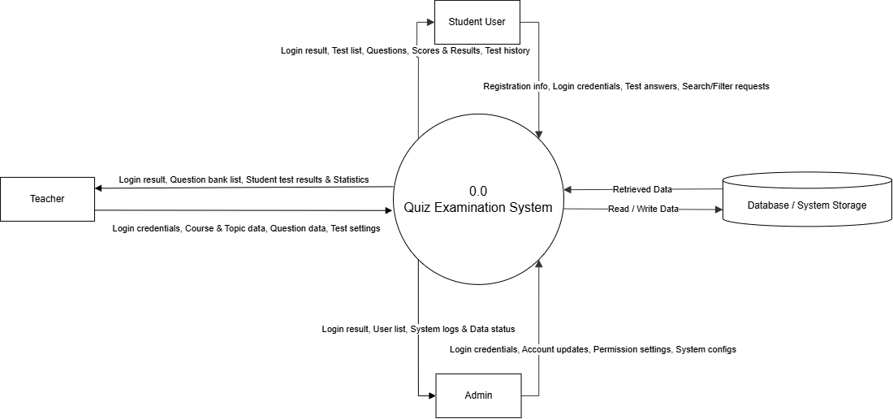

Figure 1: Data Flow Diagrams Level 0
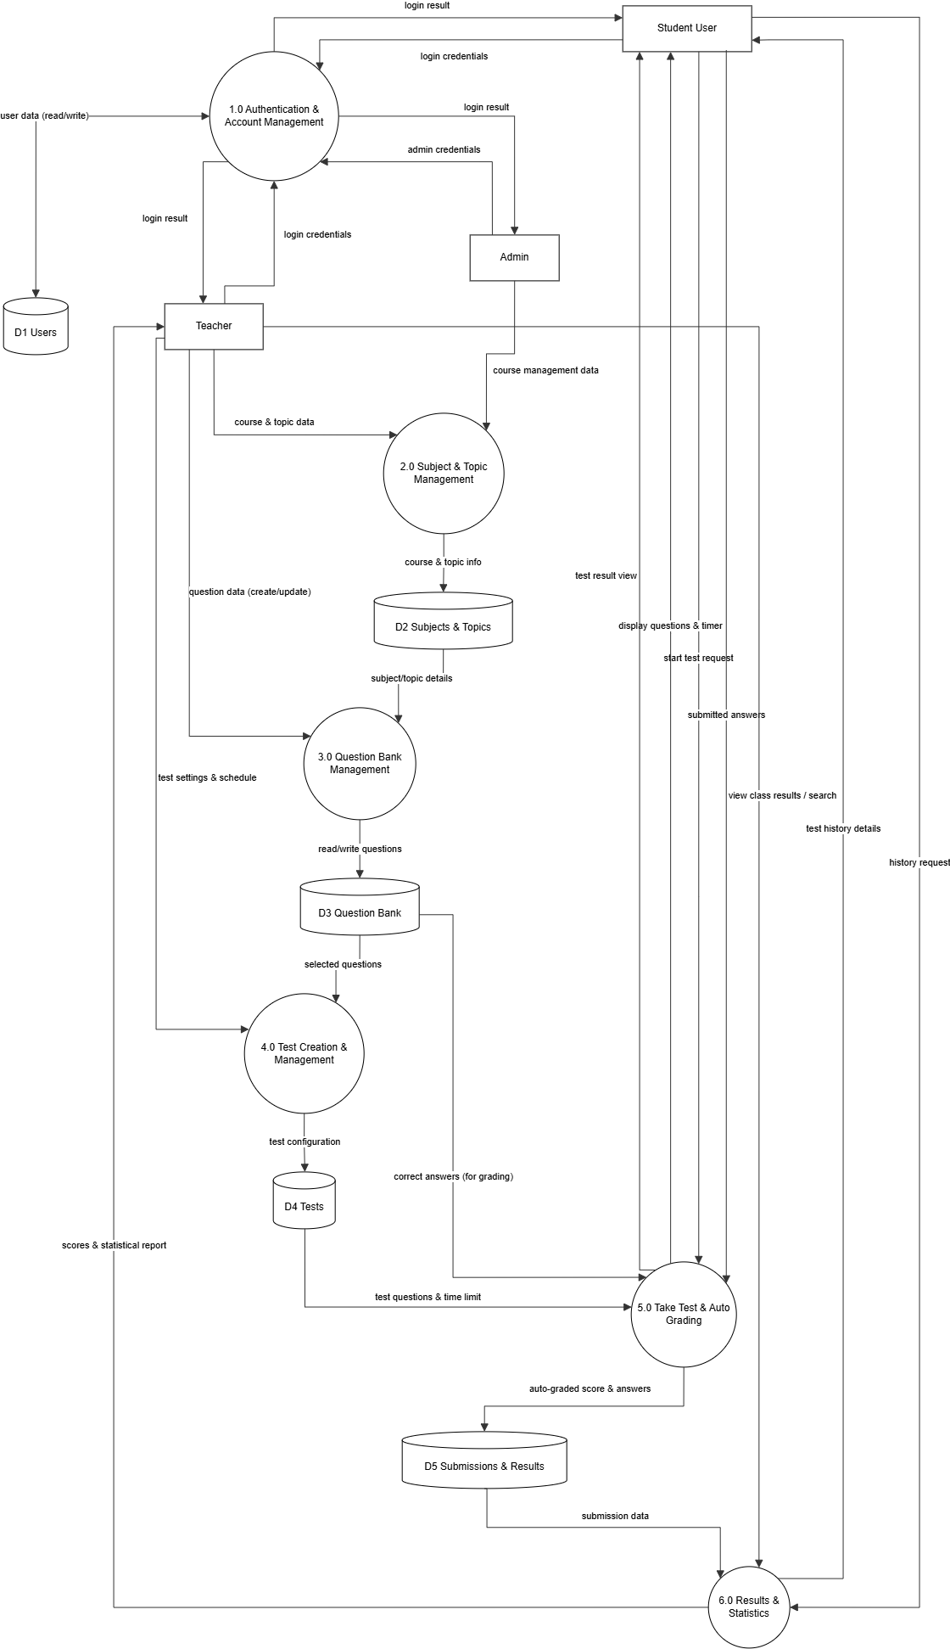
Figure 2: Data Flow Diagrams Level 1

- Use case Diagram
- Summary diagram
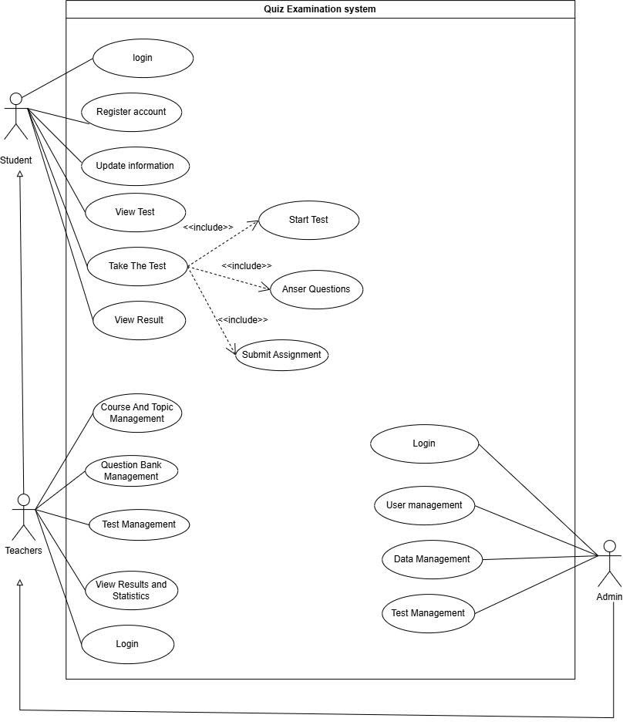

  - List of actors

NO | Actor | Meaning
1 | Students | Users taking the test on the system
2 | Teachers | Content and Test Manager
3 | Admin | System-wide administrator

  - List of use cases
STT | Use Case | Meaning
1 | Login | Users log in to the system using their account and password.
2 | Register Account | Users create new accounts to use the system.
3 | Update information | Users update their personal information.
4 | View Test | Students view the list of assigned tests.
5 | Take The Test | The student takes a test.
6 | Start Test | Start the test session, and the system begins tracking the time.
7 | Anser Questions | Students read the questions and select the answers.
8 | Submit Assignment | Students submit their work; once submitted, answers cannot be changed.
9 | View Result | Students view their test results after they have been graded.
10 | Course And Topic Management | Teachers create, edit, and delete subjects/topics.
11 | Questions Bank Management | Teachers manage the question bank: create, edit, delete, search for, and categorize questions.
12 | View Result and Statistics | The teacher views student scores and test statistics.
13 | User Management | User account management: add, edit, delete, lock/unlock, and assign permissions.
14 | Data Management | Manage system data such as questions, tests, submissions, and results.
15 | Test Management | Teachers create, edit, publish, and delete tests.

- Use-case Login
  - Summary
This use case allows users to log in to the system using a username/email and password. The system authenticates the login credentials and determines the user's role to grant appropriate access rights.
  - Timeline of events

2.2.1 Key timeline of events
1.The use case begins when the user selects the Login function.

2.The system displays the login screen.
3.The user enters their username/email and password.
4.The user selects the login function.
5.The system verifies the login information.
6.If the information is correct, the system determines the user's role.
7.The system grants the user access to functions corresponding to their permissions.

2.2.2 Other timelines
1.If the username/email or password is incorrect, the system displays an error message.
2.The user re-enters their login information.

2.3 Special requests
1.The system must protect account information.
2.The system must correctly determine user permissions.

2.4 System state prior to the execution of the use case
Not available

2.5 System state after executing the use case
Users are logged in and have access to functions corresponding to their roles.

2.6 Extension point
Not available
- Use-case Register Account
  - Summary
  - Event Flow
    - Main Event Flow
The use case begins when the student selects the Register Account function.
- The system displays the registration form.
- The student enters their full name, email, password, date of birth, and other required information.
- The student submits the registration information.
- The system checks whether the email already exists.
- If the email has not been used, the system creates a new account.
- The system notifies the student that the registration is successful.
    - Alternative Event Flows
1. If the email already exists, the system displays an error message.
2. The student is asked to use another email address.

3.3 Special Requirements
The system must check whether the registration email already exists

3.4 System state prior to the execution of the use case
For students who do not yet have an account or wish to create a new one.

3.5 System state after executing the use case
The student account is created and stored in the system.

3.6 Extension point
Not available

4 Use-case Update Information

4.1Summary
This use case allows users to update their personal information and change their password when necessary.

4.2 Timeline of events

4.2.1Key timeline of events
1.The user selects the "Update Information" function.
2.The system displays the current account information.
3.The user edits their personal information or password.
4.The user confirms the update.
5.The system saves the new information.
6.The system notifies the user that the update was successful.

4.2.2 Other timelines
Not available

4.3 Special requests
Information must be saved in the system after being updated.
  - System state prior to the execution of the use case
The user already has an account.
  - System state after executing the use case
Account information is updated and saved in the system.

4.6 Extension point
Not available
- Use-case View Test

5.1 Summary
This use case allows students to view a list of assigned tests and basic information about each test.

5.2 Timeline of events

5.2.1 Key timeline of events
1.The student selects the "View Test" function.
2.The system retrieves the list of tests assigned to the student.
3.The system displays the list of tests.
4.The system displays the test name, subject, duration, and start time.
5.The system displays the test status, such as not started, in progress, or completed.

5.2.2. Other event streams
Not available

5.3 Special requests
Not available

5.4 System state prior to the execution of the use case
The student has logged into the system.

5.5. System state after use case execution
The list of tests is displayed to students.

5.6. Extension points
Not available

6. Use-case Take The Test

6.1 Summary

6.2 Timeline of events

6.2.1 Key timeline of events
1.The student selects the test.
2.The system checks eligibility and the test duration.
3.The student starts the test.
4.The system creates a test session and begins the timer.
5.The system displays the questions and answer options.
6.The student selects an answer.
7.The system records the selected answer.
8.The student can change the answer before submitting.
9.The student completes and submits the test.
10.The system saves the submission.

6.2.2. Other event streams
1.If you do not meet the eligibility requirements, the system will not allow you to start the test.
2.If time runs out, the system automatically submits the test with the recorded answers.

6.3. Special requirements
1.The system must fully save students' work during the test.
2.The system must display the remaining time.
3.The system must respond quickly while the test is in progress.

6.4. Precondition
The student has an assigned test and meets the requirements to take it

6.5. System state after use case execution
The submission has been made and saved in the system.

6.6. Extension points
Not available

7. Use-case Start Test

7.1. Summary
This use case allows students to start a test when participation conditions are met.

7.2. Timeline of events

7.2.1. Main sequence of events
1.The student selects the test.
2.The system checks eligibility.
3.The system checks the test timing.
4.If eligible, the system creates a test session.
5.The system starts the timer.
6.The system displays the test to the student.

7.2.2. Other event streams
If the student does not meet the requirements or the test is not within the permitted timeframe, the system will not allow the test to start.

7.3. Special requirements
The system must check the timing and participation conditions before starting the lesson.

7.4. System state prior to executing the use case
The student has chosen a test.

7.5. System state after use case execution
A work session is created, and the timer starts.

7.6 Extension point
Not available

8. Use-case Answer Questions

8.1. Summary
This use case allows students to view questions, select answers, and change their answers during the test.

8.2. Timeline of events

8.2.1. Main sequence of events
1.The system displays the question and answer choices.
2.The student selects an answer.
3.The system records the answer.
4.The student can change their answer before submitting the test.
5.The system displays the remaining time.

8.2.2. Other event streams
If the time runs out, the system stops responding and automatically submits the work.

8.3. Special requirements
Students' work must be fully saved during the examination.

8.4. System state prior to the execution of the use case
The students have started the test.

8.5. System state after use case execution
The answers selected by students have been recorded by the system.

8.6. Extension points
Not available

9. Use-case Submit Assignment

9.1. Summary
This use case allows students to submit their tests after completion.

9.2. Timeline of events

9.2.1. Main sequence of events
1.The student selects the "Submit Assignment" function.
2.The system may ask the student to confirm the submission.
3.The student confirms.
4.The system records the submission.
5.The system does not allow the student to make further changes to their answers.
6.The system saves the work and the submission details.

9.2.2. Other event streams
1.If the time expires, the system will automatically submit the test.
2.The system uses the recorded answers to grade the test.

9.3. Special requirements
Once submitted, the assignment must not be lost or unintentionally altered.

9.4. System state prior to the execution of the use case
The student is taking a test.

9.5. System state after use case execution
The assignment has been submitted, and the student cannot make further changes to the answers.

9.6. Extension points
Not available

10. Use-case View Result

10.1. Summary
This use case allows students to view their test results after their work has been graded.

10.2. Timeline of events

10.2.1. Main sequence of events
1.The student selects the "View Result" function.
2.The system retrieves the test results.
3.The system displays the score.
4.The system can display the number of correct, incorrect, and unanswered questions.
5.The system can display the time taken to complete the test.
6.Depending on the teacher's settings, the system may or may not display the correct and incorrect answers.

10.2.2. Other event streams
Not available

10.3. Special requirements
Students may only view their own tests and results.

10.4. System state prior to the execution of the use case
The students' tests have been graded.

10.5. System state after use case execution
The test results are displayed to the students.

10.6. Extension points
Not available

11. Use-case Course and Topic Management

11.1. Summary
This use case allows teachers to create and manage subjects and topics within the system.

11.2. Timeline of events

11.2.1. Main sequence of events
1.The teacher selects the "Course and Topic Management" function.
2.The system displays the list of courses and topics.
3.The teacher can create a new course.
4.The teacher can add a topic to a course.
5.The teacher can edit course or topic information.
6.The teacher can delete a course or topic.
7.The system saves the changes.

11.2.2. Other event streams
Not available

11.3. Special requirements
Not available

11.4. System state prior to Use-case execution
The teacher has logged into the system.

11.5. System state after use case execution
Course and topic information has been updated in the system.

11.6. Extension points
Not available

12. Use-case Question Bank Management

12.1. Summary
This use case allows teachers to manage a question bank, including creating, editing, deleting, and searching for questions.

12.2. Timeline of events

12.2.1. Main sequence of events
1.The teacher selects Question Bank Management.
2.The system displays the question bank.
3.The teacher creates a new question.
4.The teacher enters the question content, answer options, and the correct answer.
5.The teacher assigns the question to a subject or topic.
6.The teacher sets the difficulty level.
7.The system saves the question.
8.The teacher can edit or delete the question.
9.The teacher can search for questions using keywords.
10.The teacher can filter questions by subject, topic, or difficulty level.

12.2.2. Other event streams
1.When a question is deleted, the system checks its usage status.
2.If the question is currently being used in an existing test, the system does not delete it to avoid affecting the test.

12.3. Special requirements
The system must check the usage status of the question before deleting it.

12.4. System state prior to the start of the use case execution
The teacher has logged in.

12.5. Trạng thái hệ thống sau khi thực hiện Use-case
The question bank is updated based on the teacher's actions.

12.6. Extension points
Not available

13.Use-case Test Management

13.1. Summary
This use case allows teachers to create, edit, publish, and delete tests.

13.2. Timeline of events

13.2.1. Main sequence of events
1.The teacher selects Test Management.
2.The system displays the list of tests.
3.The teacher creates a new test.
4.The teacher enters the test name, subject, duration, start time, end time, and number of questions.
5.The teacher selects questions from the question bank.
6.The teacher assigns scores to each question.
7.The system saves the test.
8.The teacher can edit test details.
9.The teacher can add or remove questions.
10.The teacher can modify the timing and test settings.
11.The teacher publishes the test for students.
12.The teacher can specify the groups or lists of students permitted to participate.
13.The teacher can delete tests that are no longer in use.

13.2.2. Other event streams
1.When deleting a test, the system checks the test's status.
2.If the status does not permit deletion, the system does not perform the deletion operation.

13.3. Special requirements
Students may only take the test during the designated time period.

13.4. System state prior to the start of the use case execution
The teacher has logged into the system.

13.5. System state after use-case execution
Test information is created or updated in the system.

13.6. Extension points
Not available

14. Use-case View Results and Statistics

14.1. Summary
This use case allows teachers to view student results and statistics related to the test.

14.2. Timeline of events

14.2.1. Main event stream
1.The teacher selects "View Results and Statistics."
2.The system displays the list of students who took the test.
3.The system displays each student's score.
4.The system displays the number of participating students.
5.The system displays the highest and lowest scores.
6.The system displays the average score.
7.The system displays the number of students who passed and failed.
8.The teacher can search for results by name or student ID.
9.The teacher can sort results by score or completion time.

14.2.2. Other event streams
Not available

14.3 Special requests
Not available

14.4. System state prior to the start of the use case execution
The teacher has logged into the system and has the result data.

14.5. System state after use-case execution
The test results and statistics are displayed.

14.6. Extension points
Not available

15. Use-case User Management

15.1. Summary
This use case allows the administrator to manage user accounts and access rights within the system.

15.2. Timeline of events

15.2.1. Main sequence of events
1.The admin selects User Management.
2.The system displays the list of accounts.
3.The admin can add accounts.
4.The admin can edit account information.
5.The admin can delete accounts.
6.The admin can lock or unlock accounts.
7.The admin can manage user permissions.
8.The system saves the changes.

15.2.2. Other event streams
Not available

15.3. Special requirements
The system must ensure that users can only access data consistent with their permissions.

15.4. System state prior to Use-case execution
The admin is logged in and has administrative privileges.

15.5. System state after executing the use case
Account information and user permissions have been updated.

15.6. Extension point
Not available

16. Use-case Data Management

16.1 Summary
This use case allows the administrator to manage system data, including questions, tests, submissions, and results.

16.2 Timeline of events

16.2.1. Main sequence of events
1.The admin selects Data Management.
2.The system displays the data groups to be managed.
3.The admin manages question information.
4.The admin manages test information.
5.The admin manages submission information.
6.The admin manages result information.
7.The system saves the changes.
8.The system ensures data access is based on user permissions.

16.2.2. Other event streams
Not available

16.3. Special requirements
1.Data must be stored securely.
2.Data must be accessed in accordance with each user's permissions.

16.4. System state prior to the start of the use case execution
The administrator has logged in and has data management privileges.

16.5. System state after use case execution
System data is updated and managed based on access rights.

16.6. Extension points
Not available

Class Diagram
  - Diagram Overview

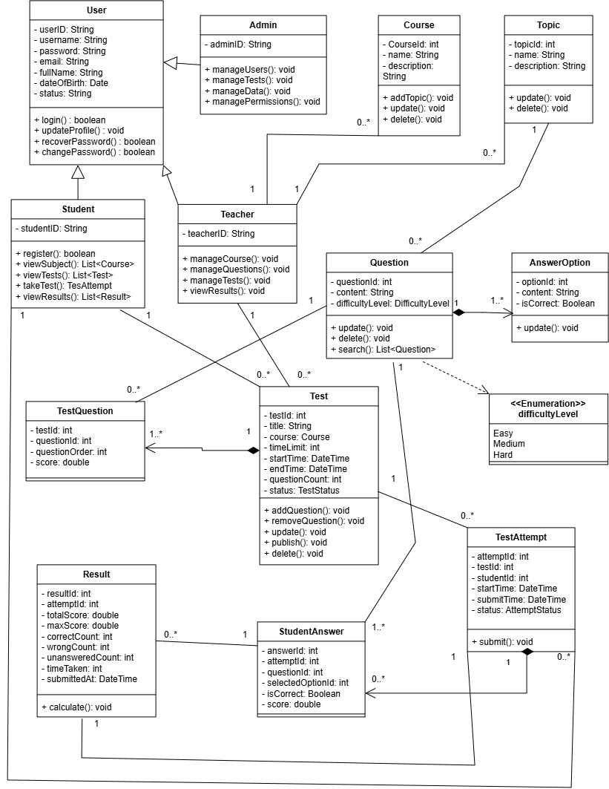

FigureV.1: ClassDiagram

DATABASE MODEL

1. Diagram Overview
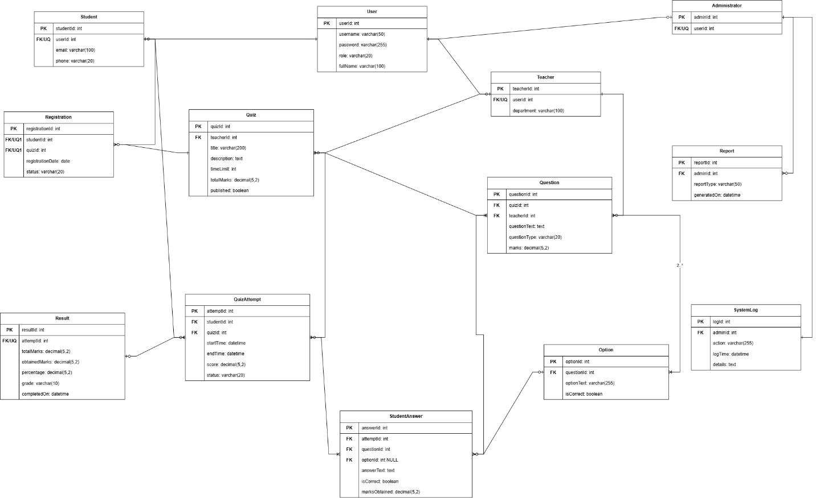
FigureV.1: Database Design

VII. Interface Design Description

1. Login Interface
- The login interface includes input fields for Username and Password, along with a Login button.
- The system authenticates the user and identifies the corresponding role: Student, Teacher, or Administrator.
- After successful authentication, the system redirects the user to the appropriate dashboard based on their role.
- If the user enters incorrect login information, the system displays a clear and understandable error message.

2. Student Interface
- After logging in, students see a dashboard that provides access to:
+ Available quizzes
+ Quiz registration
+ Quiz examinations
+ Previous quiz attempts
+ Examination results
+ Personal account information
- Available quizzes are displayed with basic information such as:
+ Quiz title
+ Description
+ Time limit
+ Total marks
+ Publication status
- Students can register for an available quiz and view their current registration status.
- Only quizzes that have been published are available for students to take.
- After completing a quiz, students can view their examination results when they become available.

3. Quiz Examination Interface
- The Quiz Examination Interface is displayed when a student starts an examination.
- Before starting the examination, the system displays:
+ Quiz title
+ Description
+ Time limit
+ Total marks
- During the examination, the system displays the questions and corresponding answer areas.
- Depending on the question type, students can:
+ Select an answer from the available options
+ Enter a written answer in a text field
- The interface displays the remaining examination time during the quiz.
- Student answers are recorded as part of the current quiz attempt.
- After completing the examination, the student selects the Submit button to submit all answers.
- The system records the completed quiz attempt and processes the examination result.

4. Teacher Interface
- Teachers have access to a dashboard that provides functions for creating and managing quizzes.
- The teacher interface provides access to:
+ Quiz management
+ Question management
+ Answer option management
+ Quiz publication
+ Student registrations
+ Quiz attempts
+ Examination results
- Teachers can create or update quiz information, including:
+ Quiz title
+ Description
+ Time limit
+ Total marks
+ Publication status
- For each quiz, teachers can create and manage questions.
- Question information includes:
+ Question content
+ Question type
+ Marks
- For questions that contain answer options, teachers can create multiple options and identify the correct answer.
- Teachers can publish a quiz after completing the quiz and question information.
- Teachers can also view student registrations, quiz attempts, and examination results related to their quizzes.

5. Result Interface
- The Result Interface displays the examination result after a student’s quiz attempt has been completed and evaluated.
- The result information includes:
+ Total marks
+ Obtained marks
+ Percentage
+ Grade
+ Completion date and time
- Students can view their previous examination results through this interface.
- Teachers can view examination results to monitor student performance in their quizzes.
- Result information is generated based on the recorded quiz attempt and submitted student answers.

6. Administrator Interface
- Administrators use a centralized dashboard to manage and monitor the Quiz Examination System.
- The administrator interface provides access to:
+ User account management
+ Student information
+ Teacher information
+ Quiz system monitoring
+ Reports
+ System logs
- Administrators can manage user accounts and control user roles in the system.
- The reporting function allows administrators to view reports related to examination activities and system usage.
- The system log interface records system activities, including:
+ User performing the action
+ Action performed
+ Execution time
+ Related details
- These functions allow administrators to monitor system activities and maintain examination data.

